1) import java.io.*;
public class Main
{
public static void main(String[] args)throws IOException
{
BufferedReader br=new BufferedReader (new InputStreamReader(System.in));
System.out.println("Author:P.Vamsi sita ram\nSAP ID:51834793");
System.out.print("Enter a number : ");
int n = Integer.parseInt(br.readLine());
int copy = n, a = 0, sum = 0;
String b = Integer.toString(n);
int len = b.length();

while(copy>0)
{
a = copy % 10;
sum = sum + (int)Math.pow(a,len);
len--;
copy = copy / 10;
}

if(sum == n)
System.out.println(n+" is a Disarium Number.");
else
System.out.println(n+" is not a Disarium Number.");
}
}
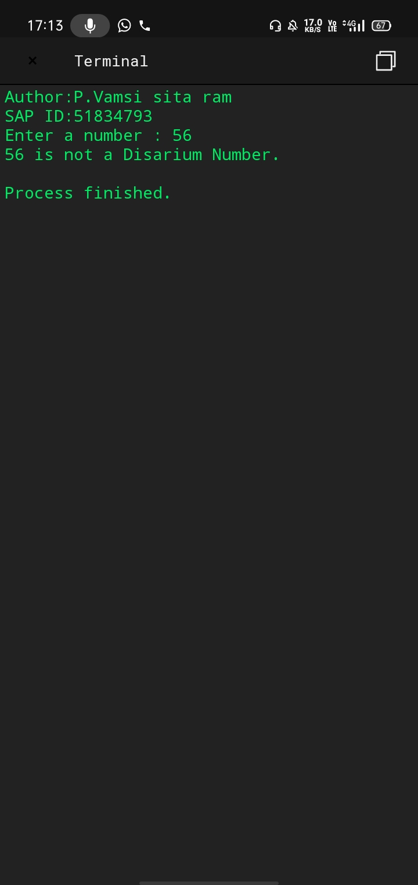
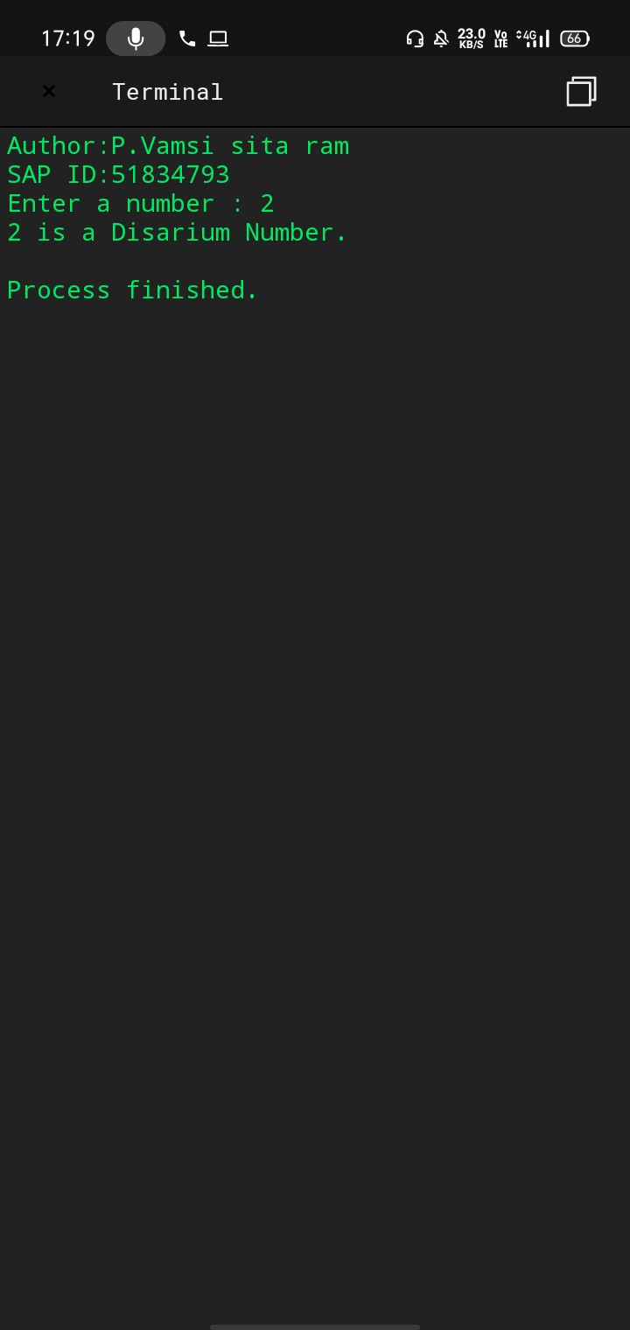

2) import java.util.Arrays;

public class Main
{
private static void sortBinaryArray(int[] inputArray)
{
int zeroCount = 0;

System.out.println("Author:P.Vamsi sita ram\nSAP ID:51834793");
System.out.println("Input Array Before Sorting : "+Arrays.toString(inputArray));

for (int n = 0; n < inputArray.length; n++)
{
if (inputArray[n] == 0)
{
zeroCount++;
}
}

for (int n = 0; n < zeroCount; n++)
{
inputArray[n] = 0;
}

for (int n = zeroCount; n < inputArray.length; n++)
{
inputArray[n] = 1;
}

System.out.println("Input Array After Sorting : "+Arrays.toString(inputArray));
}

public static void main(String[] args)
{
sortBinaryArray(new int[] {1, 0, 1, 1, 0, 1, 0, 0});
}
}

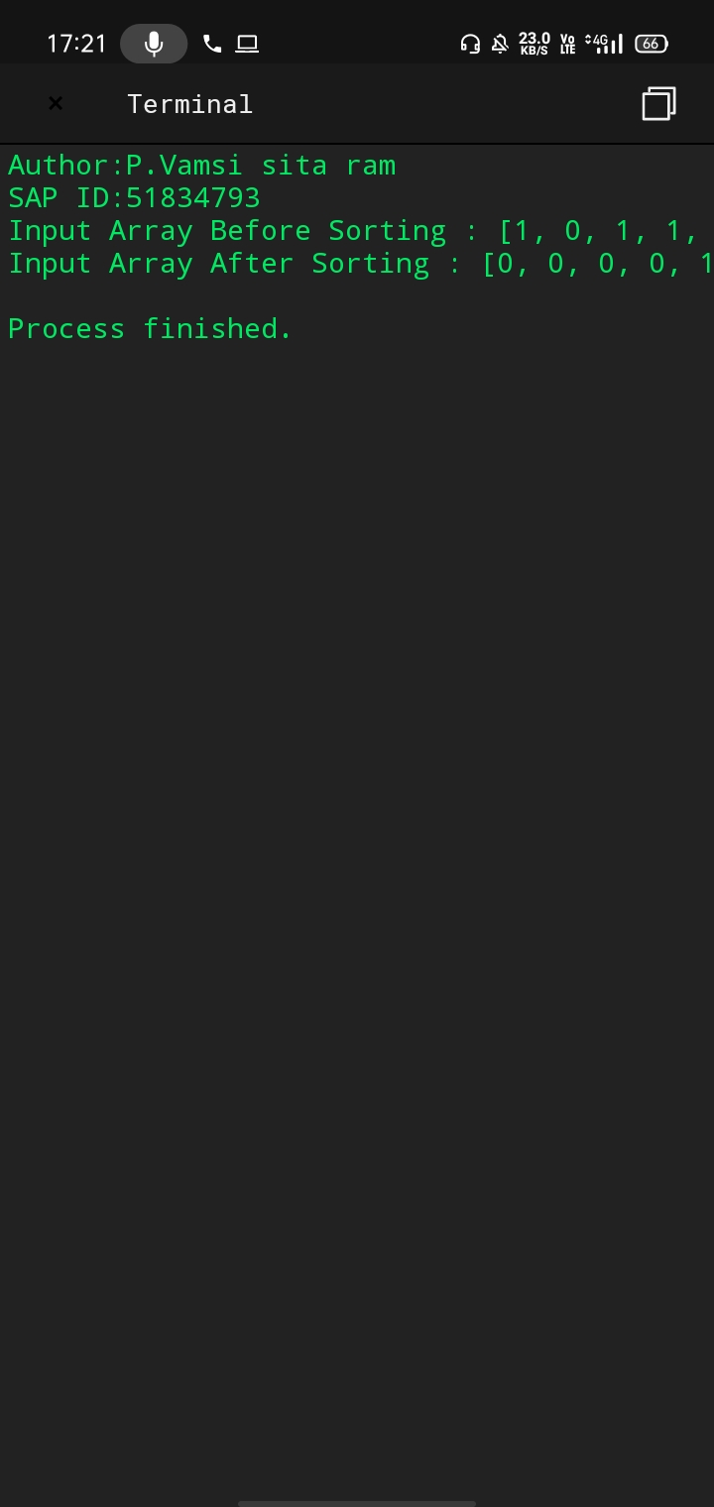

3)public class Main
{
static int replaceDigit(int a, int numbertobereplaced,
int replacingnumber)
{
int result = 0, multiply = 1;

while (a % 10 > 0)
{

int remainder = a % 10;

if (remainder == numbertobereplaced)
result = result + replacingnumber * multiply;

else
result = result + remainder * multiply;

multiply *= 10;
a = a / 10;
}
return result;
}

public static void main(String[] args)
{
int a = 645, numbertobereplaced = 6, replacingnumber = 5;
System.out.println("Author:D.P.Vamsi sita ram\nSAP ID:51834793");
System.out.println(replaceDigit(a, numbertobereplaced, replacingnumber));
}
}

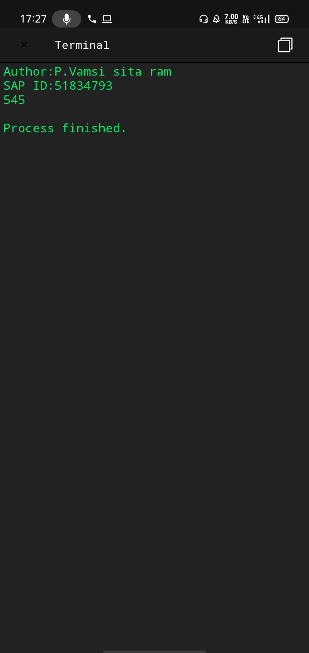

5)public class Main
{
public static int binarySearch(int[] M, int left, int right, int n)
{
if (left > right) {
return -1;
}

int mid = (left + right) / 2;

if (n == M[mid]) {
return mid;
}

else if (n < M[mid]) {
return binarySearch(M, left, mid - 1, n);
}

else {
return binarySearch(M, mid + 1, right, n);
}
}

public static void main(String[] args)
{
int[] M = { 2, 5, 6, 8, 9, 10 };
int key = 3;

int left = 0;
int right = M.length - 1;

int index = binarySearch(M, left, right, key);

System.out.println("Author:P.Vamsi sita ram\nSAP ID: 51834793");
if (index != -1) {
System.out.println("Element found at index " + index);
} else {
System.out.println("Element not found in the array");
}
}
}
